RED & GREEN EINKORN PASTA SALAD
From Kathryn Conlen’s Kitchen
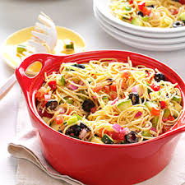

Prep Time: 20 Minutes Cook Time: 10 Minutes
Serves: 9
INGREDIENTS
8oz YL Einkorn Pasta
½ Purple Onion (medium, sliced or minced)
15oz Black Olives (drained, recommend Kalamata Olives)
2/3 cup Feta Cheese Crumbles
1 Salad Dressing to taste (recommend Greek)
3 Tbsps. fresh Oregano
3 Tbsps. fresh Marjoram
¼ cup fresh Basil

Seasonal Extras for Red/Green Color:
1 Cucumber, chopped
1 Red Bell pepper, chopped

PREPARATION
Prepare pasta as directed on package. Rinse with cold water. Chop and prepare other vegetables. Mix ingredients and add salad dressing. Serve chilled.

