PALEO CHOCOLATE ORANGE TRUFFLES

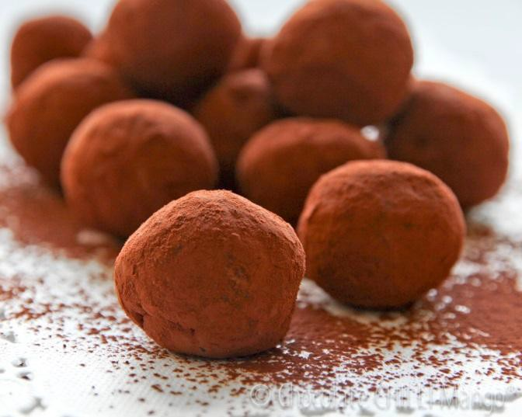
Prep Time: 20 Minutes Fridge Time: 1-1/2 hours
Serves: 8-10 servings

INGREDIENTS
12 oz dark chocolate
1 cup full-fat coconut milk 1 Tbsp maple syrup
1-2 drops YL Orange Essential Oil Dash of sea salt
½ cup cocoa powder for rolling

PREPARATION
Break up chocolate into pieces if it’s in bark form. In a pot, heat the coconut milk and chocolate. Add maple syrup. Mix until combined. The mixture will be thick and look somewhat gooey.

Remove from the heat; add a dash of sea salt and YL Lavender Essential Oil. Set the bowl in the refrigerator for 4-6 hours or in the freezer for 1 hour.

Remove from refrigerator. Set on the counter to soften for a few minutes before scooping. Scoop out about ½ inch balls with a spoon and lay them out on a parchment paper-covered board. Refrigerate for about 30 minutes.

Roll truffle balls with your hands to make them evenly round. Roll truffles in cocoa powder and serve.

Note: Keep refrigerated when not in use.

