Orange Cranberry Sauce
From Jackie Jeuckstock’s Kitchen
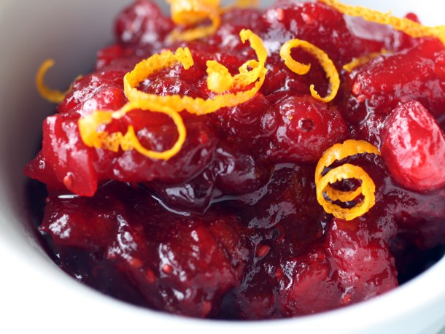
Prep Time: 10 Minutes Cook Time: 60 Minutes
Serves: 6-8
INGREDIENTS
8 oz Organic Cranberries
2/3 cup Organic fresh squeezed orange juice
2-4 Tbsp. YL Blue Agave or other natural sweetener
2-4 drops YL Orange Essential Oil (may substitute YL Tangerine Essential Oil)

PREPARATION
Place cranberries and fresh squeezed orange juice in a medium sauce pan on medium heat. Cook about 45-60 minutes until desired consistency. Cool completely and add 2-4 drops of YL Orange Essential Oil.

