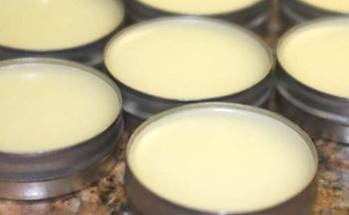
LIP BALM

SUPPLIES
Small tin or lip balm container
½ cup olive oil, coconut oil or almond oil
2 level Tbsps. of beeswax pastilles
5-10 drops of your favorite YL Essential Oil

PREPARATION

Melt beeswax with oil of choice in a double boiler until just melted. Add the essential oils once melted. Stir until well mixed and pour into container with a lid to store.

