LEMON POPPY SEED PANCAKES
From Kathryn Conlen’s Kitchen
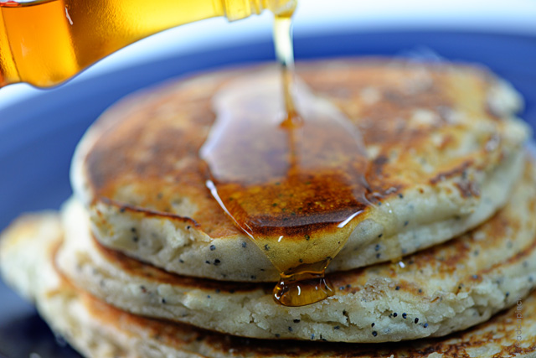
Prep Time: 10 Minutes Cook Time: 10 Minutes
Serves: 3-5
INGREDIENTS
1½ cup YL Einkorn Flour
1-1/2 tsp Baking Powder
1 tsp Baking Soda
1 Tbls Raw Coconut Palm Sugar or Raw Cane Sugar
4 Organic Eggs
½ cup Organic Grapeseed Oil
1-1/2 tsp Vanilla Extract or 1-2 Drops YL Vanilla Essential Oil
1 cup Unsweetened Rice, Almond or Coconut Milk (water can be used)
2 Tablespoons Poppy Seeds
10 Drops YL Lemon Essential Oil
3 Tablespoons Organic Fresh Squeezed Lemon Juice

PREPARATION
Mix ingredients. Pour on pre-heated griddle or pan and cook until cooked through and golden brown on both sides. Top with fruit, YL Ningxia Berry Syrup or maple syrup.

