Cinnamon Apple Sauce
From Jackie Jueckstock’s Kitchen
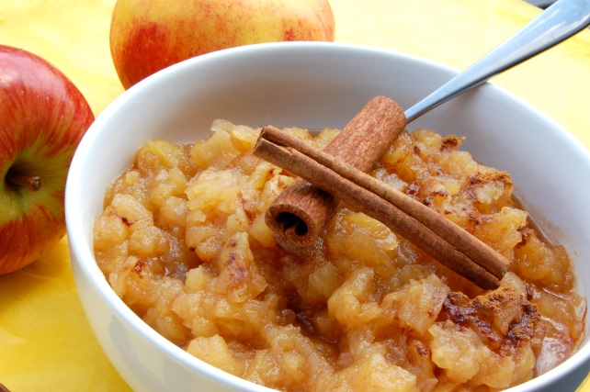

Prep Time: 30 mins Cook Time: 45 Minutes
Serves: 5-6

INGREDIENTS
20-25 medium-sized Courtland Apples
1-3 drops YL Lemon Essential Oil; YL Cinnamon Bark Oil
1/2 cup Xylitol

PREPARATION
Peel and core the apples. Chop them into 1-2 inch sized pieces. Add 1-3 drops of lemon oil to prevent browning. Place apples with lemon oil in a pot on medium heat and add Xylitol. Cook until apples become a sauce, stirring occasionally. Use a potato masher to help mash the apples. After apples are cooked to your desired consistency, turn off the heat. Cool completely and add 3-4 drops of cinnamon oil. You may also want to try 2 drops cinnamon and 2 drops orange oil for a little different flavor! Serve.

