BATH SALTS
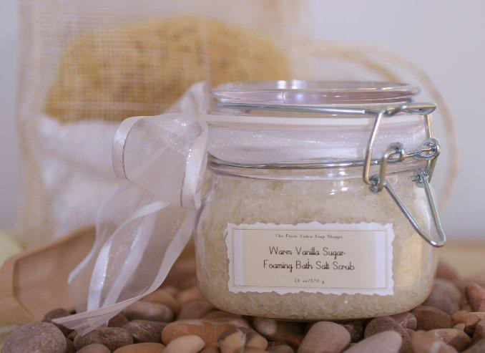

SUPPLIES
4 or 8 oz Glass Jars
4 or 8 oz Coarse Sea Salt or Epsom Salt V-6 Vegetable Oil to desired saturation 15-20 Drops of YL Essential Oils

PREPARATION
Mix all ingredients in glass container. Add to hot bath. Enjoy!

Bath Blends to try…… Nighty Night
10 drops Lavender EO
5 drops German or Roman Chamomile EO

Soothe My Soul
5 Drops Geranium EO 5 Drops Lavender EO
5 Drops Inner Child, Dream Catcher or Ylang Ylang EO

Stress Be Gone
5 drops StressAway 15 drops Jade Lemon

Breathing Better Already
10 drops Eucalyptus Radiata or Globulus or (RC blend) 5 drops Rosemary
3 Drops Peppermint

Little Snifflers Soak
10 drops Kidscent SniffleEase 5 Drops Lavender
5 Drops RC

Lavender & Oatmeal Bath Salts
1 cup Epsom Salt 1 cup Oatmeal
1 Tbsp. Dried Lavender
20 Drops YL Lavender Essential Oil

