APPLE ENERGIZER SMOOTHIE
From Kathryn Conlen’s Kitchen
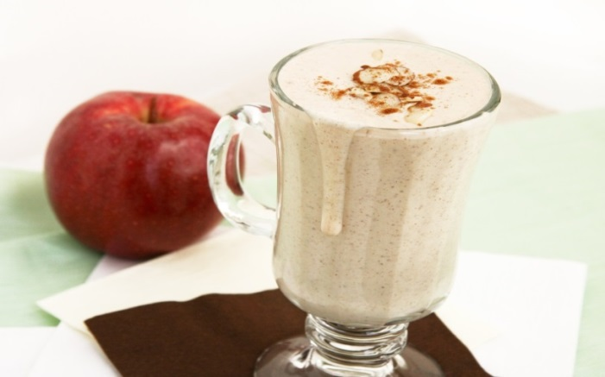
Prep Time: 5-10 Minutes Serves: 2-10oz smoothies
INGREDIENTS
2 scoops YL Pure Protein Complete (Vanilla)
2 Tbsps. Creamy Organic Peanut or Almond Butter
1 large Apple, peeled and cored
2 spoonful’s Plain Organic Greek Yogurt
Honey to taste
1 cup Ice
½ cup Water or Organic Almond, Rice or Coconut Milk

PREPARATION
Combine and blend ingredients in blender to desired consistency.

